**PROJECT WORK: BOAT LIFESTYLE**

**PROJECT TITLE: Comprehensive Digital Marketing**

**Name: P.Syadabi**

**Team Id: LTVIP2025TMID21817**

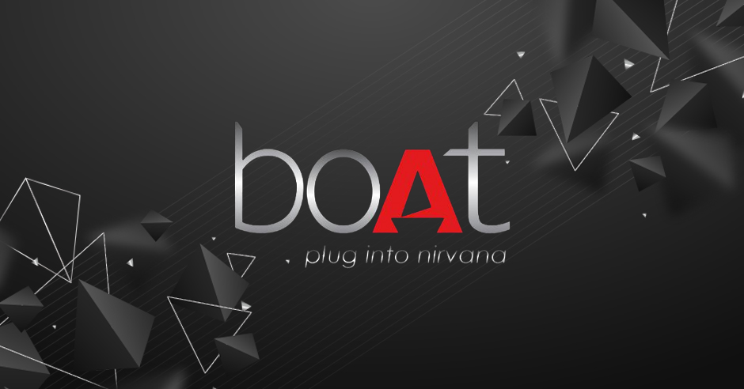

**PROJECT WORK: BOAT LIFESTYLE**

**ABOUT THE BOAT LIFESTYLE:**

**BOAt Lifestyle is a leading Indian brand in the consumer electronics industry, particularly known for its audio products and smart wearables. Founded in 2016 by Aman Gupta and Sameer Mehta, the company has disrupted the Indian market with its stylish, affordable, and high-quality products.**

**The boat lifestyle is an adventurous and unique way of living that revolves around life on the water, where individuals or families choose to live or travel aboard boats instead of staying in traditional homes**.

**Boat life is a way to escape the hustle and bustle of land-based routines, providing a minimalist yet fulfilling lifestyle. It offers a closer connection to nature, a sense of freedom, and the ability to travel to remote, picturesque locations that aren't easily accessible by land.** **While some may live aboard permanently, others may use their boats for occasional vacations or extended trips, enjoying the flexibility and excitement that comes with being constantly on the move.**

**BoAt’s product line has expanded significantly since its inception, now offering a range of products including:**

**- Audio Products: headphones, earphones, speakers, and soundbars**

**- Smart Wearables: smartwatches**

**- Accessories: charging cables, chargers, and more**

**The company’s success can be attributed to its focus on providing high-quality products at affordable prices, along with its trendy and eye-catching designs. BoAt has also established a strong online presence through social media and influencer marketing .**

**In terms of its market presence, BoAt is available on various online platforms, including Amazon, Flipkart, and Myntra, as well as its official website. The brand has seen immense profit gain in the past five years and is considered one of India’s fastest-growing electronic gadgets companies.**



**A comprehensive digital marketing strategy for BoAt Lifestyle! This approach encompasses various digital platforms and tactics to propel the brand’s growth, engage with its target audience, and establish itself as a thought leader in the audio industry.**

**Key takeaways from this strategy:**

**1. Multichannel presence:** **boat life involves establishing a strong presence across several platforms and channels**, **Leverage social media, search engines, e-commerce channels, and email marketing to reach the target audience.**

**2. Content marketing: Create engaging content (blog posts, videos, interactive campaigns) to showcase products and establish thought leadership.**

**3. Personalization: whether you're focused on adventure, relaxation, sustainability, or community. Use email marketing and influencer partnerships to nurture customer relationships and drive repeat purchases.**

**4. Optimization and advertising: Optimize the website for search engines and implement targeted advertising campaigns to enhance online visibility.**

**5. Emerging technologies:** **Innovations in navigation and energy systems to advances in smart technologies and automation**, **Utilize AR and VR to provide immersive experiences and interact with customers virtually.**

**6. Data-driven approach: Continuously analyze data and metrics to refine digital marketing efforts and ensure maximum ROI.**

**By adopting this holistic digital marketing approach, BoAt Lifestyle can:**

**1. Solidify its market leadership**

**2. Enhance customer engagement and loyalty**

**3. Drive business growth and revenue**

**4. Stay ahead of competitors in the digital landscape**

**A well-rounded strategy to propel BoAt Lifestyle’s digital presence and success!**

**BRAND STUDY,COMPETITOR ANALYSIS AND BUYER’S/AUDIENCE’S PERSONA:**

**A comprehensive milestone! Let’s break down each activity:**

**1.BRAND STUDY:**

**Conduct an in-depth analysis of the brand, including:**

**- Brand history: Understand the brand’s origins, evolution, and milestones.**

**- Brand positioning: Identify the brand’s unique value proposition, target audience, and competitive landscape.**

**- Brand identity: Brand identity must communicate a sense of reliability**, **innovation**, **durability**, and **performance in marine environments**, **Analyze the brand’s visual identity (logos, colors, typography), tone, and language.**

**- Brand messaging:** **Boat is essential to communicate a value proposition clearly and effectively to its target audience. Since boat play a vital role in ensuring safety, performance the messaging needs to convey** **reliability**, **innovation**, **precision**, and **ease of use**. **Review the brand’s key messages, taglines, and elevator pitches.**

**- Brand performance**: **The performance of a brand in the boat industry hinges on its ability to meet the specific needs of boaters, technology, and maintain high levels of reliability and customer trust and** **Evaluate the brand’s current performance, including metrics like website traffic, social media engagement, and sales.**

**2.COMPETITOR ANALYSIS:**

**Research and analyze the brand’s competitors, including:**

**- Identifying competitors: Determine the brand’s direct and indirect competitors.**

**- Competitor profiling: Gather information about competitor’s strengths, weaknesses, and market positioning.**

**- Competitor benchmarking: Compare the brand’s performance metrics (e.g., website traffic, social media**

**- Competitor SWOT analysis: Identify the competitors’ strengths, weaknesses, opportunities, and threats.**

**3.BUYER’S/AUDIENCE’S PRRSONA:**

**Detailed profile of the brand’s ideal customer, including:**

**- Demographics: Age, gender, income, occupation, education, etc.**

**- Goals and challenges: Identify the customer’s goals, pain points, and challenges related to the brand’s products or services.**

**- Behavior patterns: Understand the customer’s behavior patterns, including their online activities, purchasing habits, and social media engagement.**

**- Preferred communication channels: Determine the customer’s preferred communication channels, such as email, social media, phone, or in-person.**

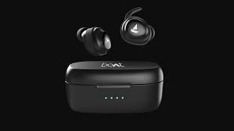**By completing these activities, you’ll gain a deeper understanding of the brand, its competitors, and its target audience, ultimately informing a more effective marketing strategy.**

**SEO AND KEYWORD RESEARCH:**

**A crucial milestone for improving website visibility and search engine rankings! Let’s dive into each activity:**

**1.SEO AUDIT:**

**Conduct a comprehensive SEO audit to identify areas for improvement, including:**

**- Technical SEO:** **The backbone of your website's ability to be indexed, crawled, and ranked by search engines.** **Analyzing website structure, crawlability, mobile responsiveness, page speed, and XML sitemaps.**

**1. Website Structure & URL Optimization: logical, and well-organized website structure allows search engines to crawl your pages more effectively, and provides a better user experience (UX).**

**2. Crawlability:** **Search engines can crawl and index your pages effectively is crucial for visibility in search engine results. And refers to how easily search engines like Google bot can access and navigate to website**

**3. Mobile Responsiveness: users are accessing websites via mobile devices**, **Google prioritizes mobile-first indexing**. **A responsive website adjusts content to fit the screen size of the device.**

**- On-page SEO:** **crucial part of optimizing your boat to improve its visibility in search engines and provide a better user experience**.  **Review meta tags, titles, descriptions, headings, content quality, and internal linking.**

**- Link equity: Assess the quality and quantity of backlinks, anchor text diversity, and link spam.**

**- Content quality: Evaluate content relevance, uniqueness, and engagement metrics (e.g., bounce rate, time on page).**

**- Local SEO: Verify Google My Business listing, citations, and local directory presence (if applicable).**

**2.KEYWORD RESEARCH:**

**Perform keyword research to identify relevant and high-traffic search terms, including:**

**- Keyword brainstorming: Use tools like Google Keyword Planner, Ahrefs, or SEMrush to generate keyword ideas.**

**- Keyword analysis: Evaluate keyword metrics like search volume, competition, cost-per-click (CPC), and relevance.**

**- Long-tail keywords: Identify specific phrases with lower competition and higher conversion rates.**

**- Keyword clustering: Group related keywords to create content themes and topic clusters.**

**3.ON PAGE OPTIMIZATION :**

**Implement on-page optimization techniques to improve website elements and content, including:**

**- Title tags:** **Title tags are one of the most important on-page SEO factors Write unique, descriptive, and keyword-rich title tags for each page.**

**- Meta descriptions: Craft compelling and informative meta descriptions to entice users to click.**

**- Header tags: The content for both search engines and users. Proper use of headers ensures your page is easy to read and understand**. **Organize content using header tags (H1, H2, H3, etc.) for structure and readability.**

**- Content Quality & optimization: Incorporate target keywords naturally into high-quality, engaging, and informative content.**

**4. URL Structure: The URL structure helps search engines understand, and it also improves the user experience.**

**- Image optimization:** **Optimizing images improves page load speed and ensures that they are discoverable in Google Image Search**. **Use descriptive alt tags, file names, and compress images to improve page load times.**

**By completing these activities, you’ll be able to:**

**- Identify and address SEO issues**

**- Develop a keyword strategy to target relevant search terms**

**- Optimize website elements and content for improved search engine rankings and user experience**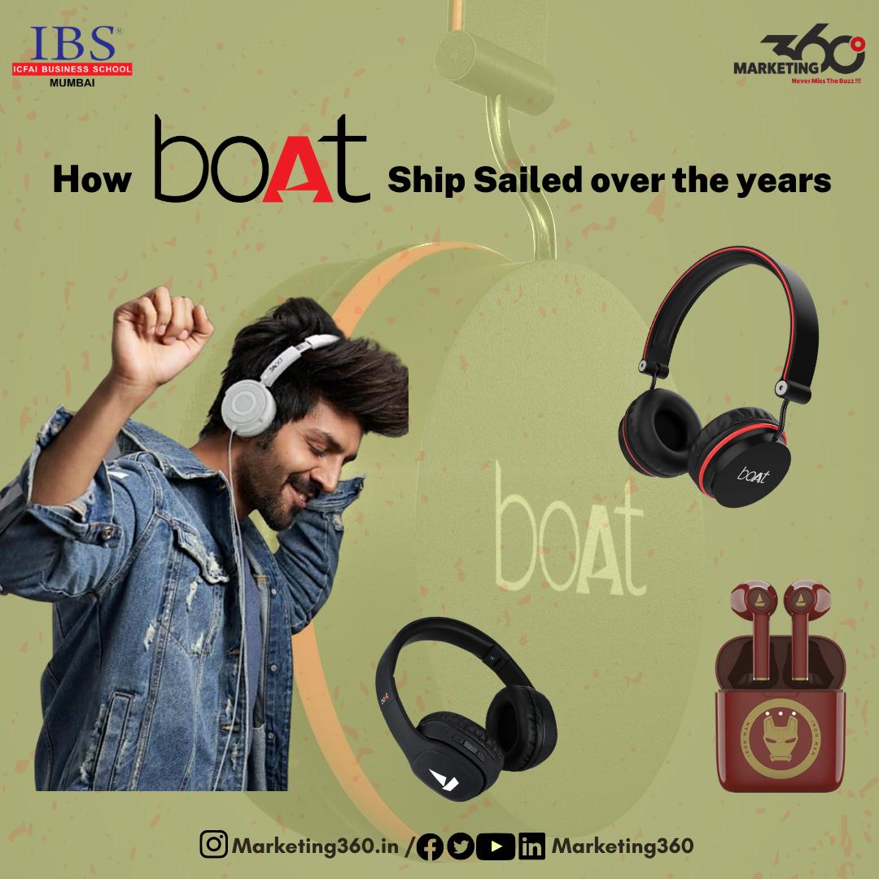

**CONTENT IDEAS AND MARKETING STRATEGIES:**

**Let’s dive into each activity:**

**1.CONTENT IDEAS & Strategy:**

**Generate a list of content ideas to attract and engage the target audience, including:**

**Blog posts:**

**-Product reviews and tutorials**

**-Industry trends and news**

**-Listicles (e.g., “Top 10 Tips”)**

**-Thought leadership pieces**

**Social media content:**

**•Behind-the-scenes stories**

**•User-generated content campaigns**

**•Infographics and visual content**

**•Live streaming and Q&A sessions**

**Video content:**

**\*Product demos and explainers**

**\*Customer testimonials and success stories**

**\*Educational and how-to content**

**\*Brand storytelling and documentaries**

**Podcast and audio content:**

**••Interviews with industry experts**

**••Panel discussions and debates**

**••Audio blogs and news updates**

**••Storytelling and narrative podcasts**

**E-books and guides:**

**\*\*Comprehensive guides to industry topics**

**\*\*Whitepapers and research reports**

**\*\*Case studies and success stories**

**\*\*Checklists and templates**

**2.MARKETING STRATEGIES: Develop a list of marketing strategies to promote the content and reach the target audience, including:**

**Content Marketing:**

**=>Publish High-Quality Blog Posts**:

**Social Media Marketing**

**=>Targeted Social Media Ads**

**Influencer Marketing:**

**=>Partner with Boating Influencers and Experts**

**Email marketing:**

**=>Newsletters and promotional emails**

**=>Automated email sequences and workflows**

**=>Personalized and targeted email campaigns**

**Influencer marketing:**

**<>Partnering with industry influencers and thought leaders**

**<>Sponsored content and product placements**

**<>Influencer takeovers and guest posts**

**Paid advertising:**

**()Google Ads and search engine marketing**

**()Social media advertising (e.g., Facebook, LinkedIn, Twitter)**

**()Native advertising and sponsored content**

**Content partnerships and collaborations:**

**#Guest blogging and content swaps**

**#Collaborative content projects and research studies**

**#Partnerships with other brands and businesses**

**Event marketing and webinars:**

**..Hosting webinars and online events**

**..Participating in industry conferences and trade shows**

**..Spons opportunities orship and exhibition**

**By generating content ideas and marketing strategies, you’ll be able to:**

**~Create a content calendar and plan**

**~Develop a marketing strategy and budget**

**~Attract and engage the target audience**

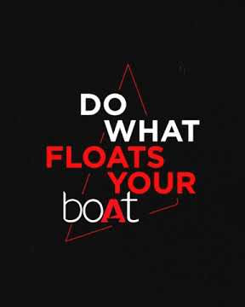**~Drive traffic, leads, and sales**

**CONTENT CREATION AND CURATION:**

**A comprehensive content creation and curation project! Let’s break down each task:**

**1.POST CREATION:**

**Develop a content calendar and create high-quality, engaging posts for social media platforms, including:**

**-Blog posts: Write informative, entertaining, and optimized articles for the website blog.**

**- Social media posts: Craft platform-specific content, such as Facebook posts, Twitter threads, Instagram captions, and LinkedIn articles.**

**- Caption writing: Write compelling, concise, and engaging captions for social media posts.**

**2.DESIGN/VIDEO EDITING:**

**Create visually appealing and engaging visual content, including:**

**- Graphic design: Designs should highlight the innovation, high-tech nature, and practicality of the products, while also engaging your target** **audience Design social media graphics, blog post headers, and other visual elements.**

**- Video editing: Editing the high-quality videos Edit and produce high-quality videos for social media, website, and advertising campaigns.**

**- Animation and motion graphics: Create animated explainers, logos, and other motion graphics elements.**

**3.ADS CAMPAIGN OVER SOCIAL MEDIA:**

**Develop and execute targeted social media ad campaigns to reach the desired audience, including and requires a strategic approach across platforms like Facebook,** **Twitter, and LinkedIn**.

**- Facebook and Instagram ads: Create and manage ad campaigns on Facebook and Instagram.**

**- Twitter ads: Develop and execute ad campaigns on Twitter.**

**- LinkedIn ads: Create and manage ad campaigns on LinkedIn.**

**- Ad targeting and optimization: Target specific audiences, optimize ad performance, and monitor ad metrics.**

**4.EMAIL IDEATION AND CREATION:**

**Develop and create engaging email campaigns to nurture leads and encourage conversions, including:**

**- Email newsletters: Design and write regular newsletters to subscribers.**

**- Promotional emails: Create promotional emails for specific products, services, or events.**

**- Automated email sequences: Develop automated email sequences for lead nurturing and onboarding.**

**- Email templates and design: Design and create email templates for various campaigns and purposes.**

**By completing these tasks, you’ll be able to:**

**- Create a robust content library**

**- Engage audiences across social media platforms**

**- Drive website traffic and conversions**

**- Nurture leads and encourage conversions through email marketing**

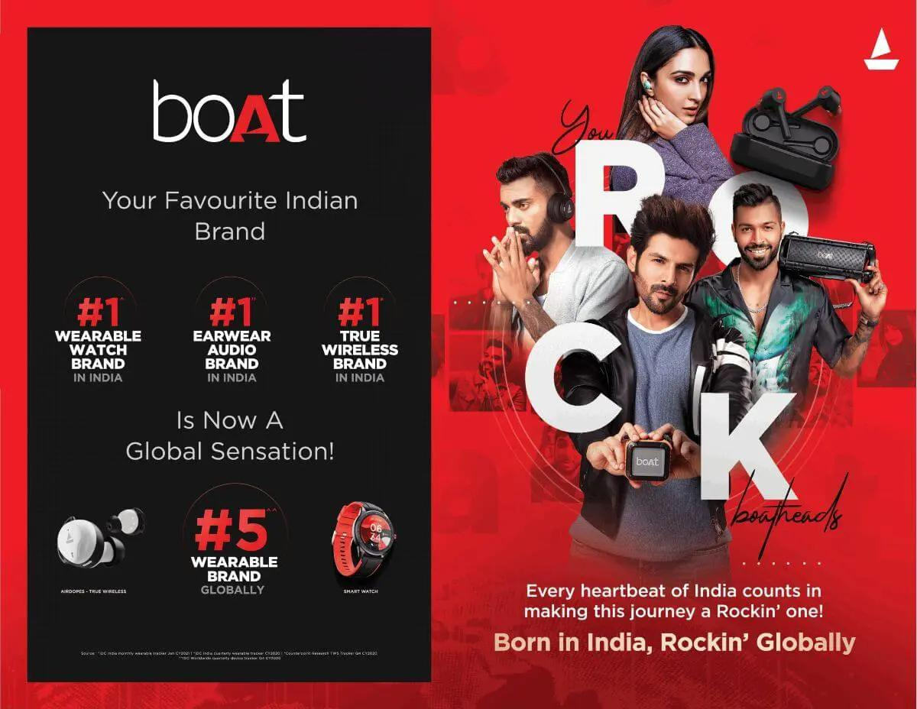

**WHAT ARE AVAILABLE IN BOAT LIFESTYLE COMPANY:**

**BoAt Lifestyle offers a wide range of products, including:**

**- Audio Products:**

**- _Headphones_: wireless, wired, and gaming headphones**

**- _Earbuds_: wireless, wired, and true wireless earbuds**

**- _Speakers_: portable speakers, soundbars, and home audio systems**

**- Wearable Devices:**

**- _Smartwatches_: stylish and feature-packed smartwatches**

**- Mobile Accessories:**

**- _Cables and Chargers_: durable and high-quality cables and chargers**

**- Home Audio:**

**- _Soundbars_: sleek and powerful soundbars for home entertainment**

**BoAt Lifestyle is known for its affordable, durable, and fashionable products, making it a popular choice among millennials and Gen-Z customers in India.**

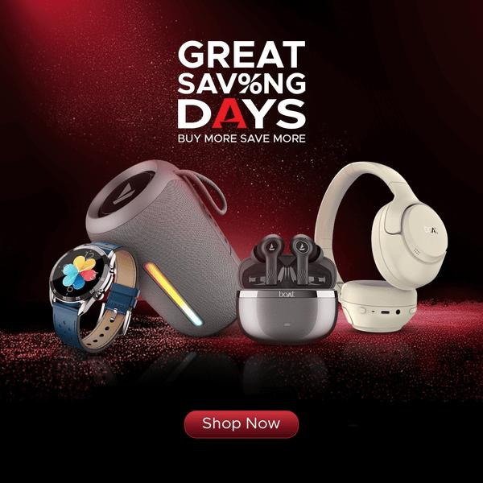

**BENEFITS TO CUSTOMER FROM THE BOAT LIFESTYLE COMPANY:**

**Here are the benefits that customers can expect from Boat Lifestyle:**

**Product-Related Benefits:**

**1. High-quality audio products: Boat Lifestyle offers high-quality audio products that provide an immersive listening experience.**

**2. Stylish and durable designs: Boat Lifestyle products are designed to be stylish, durable, and long-lasting.**

**3. Affordable prices: Boat Lifestyle products are priced affordably, making high-quality audio accessible to a wider audience.**

**Customer Experience Benefits:**

**1. Easy purchasing process: Boat Lifestyle offers a seamless online shopping experience, with easy navigation and secure payment processing.**

**2. Excellent customer support: Boat Lifestyle provides dedicated customer support, with responsive customer service and comprehensive FAQs.**

**3. Regular updates and software enhancements: Boat Lifestyle regularly updates its products with new features, software enhancements, and performance improvements.**

**Value-Added Benefits:**

**1. Warranty and after-sales support: Boat Lifestyle offers a comprehensive warranty and after-sales support, providing customers with peace of mind and protection for their investment.**

**2. Exclusive promotions and offers: Boat Lifestyle rewards its customers with exclusive promotions, discounts, and limited-time offers.**

**3. Loyalty program: Boat Lifestyle has a loyalty program that rewards repeat customers with points, discounts, and other benefits.**

**4.Enhanced entertainment experiences: Boat Lifestyle products enable customers to enjoy their favorite music, movies, and games with immersive, high-quality sound.**

**5.Increased productivity and focus: Boat Lifestyle products, such as wireless earbuds and headphones, help customers stay focused and productive in their daily lives.**

**6.Sense of style and sophistication: Boat Lifestyle products are designed to be stylish and sophisticated, making customers feel confident and fashionable when using them.**

**By offering these benefits, Boat Lifestyle builds strong relationships with its customers, fosters loyalty, and drives business growth through positive word-of-mouth and repeat business.**

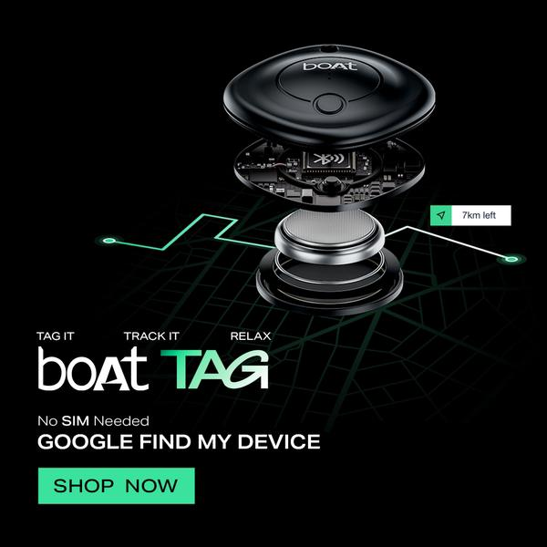

**MERITS TO CUSTOMER FROM THE BOAT LIFESTYLE COMPANY**

**They are**

**Product Merits:**

**1. High-quality products: Boat Lifestyle offers high-quality products that provide excellent performance and durability.**

**2. Innovative designs: Boat Lifestyle products feature innovative designs that combine style, functionality, and comfort.**

**3. Affordable prices: Boat Lifestyle products are priced affordably, making high-quality audio and lifestyle products accessible to a wider audience.**

**Service Merits:**

**1. Excellent customer support: Boat Lifestyle provides dedicated customer support, with responsive customer service and comprehensive FAQs.**

**2. Easy returns and refunds: Boat Lifestyle offers easy returns and refunds, ensuring that customers are satisfied with their purchases.**

**3. Regular updates and software enhancements: Boat Lifestyle regularly updates its products with new features,**

**software enhancements, and performance improvements.**

**Warranty and After-Sales Merits:**

**1. Comprehensive warranty: Boat Lifestyle offers a comprehensive warranty that covers manufacturing defects and other issues.**

**2. Dedicated after-sales support: Boat Lifestyle provides dedicated after-sales support, ensuring that customers receive assistance with any issues or concerns.**

**3. Repair and replacement services: Boat Lifestyle offers repair and replacement services for damaged or defective products.**

**Loyalty and Rewards Merits:**

**1. Loyalty program: Boat Lifestyle has a loyalty program that rewards repeat customers with points, discounts, and other benefits.**

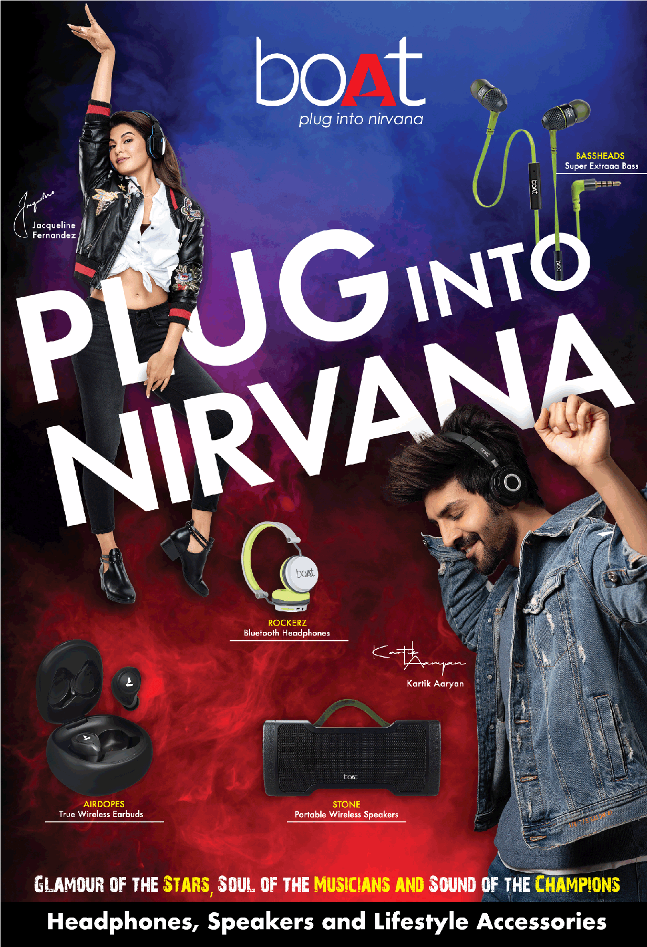**2. Exclusive offers and promotions: Boat Lifestyle offers exclusive offers and promotions to its loyal customers, providing them with additional value and savings.**

**3. Early access to new products: Boat Lifestyle provides its loyal customers with early access to new products, allowing them to experience the latest innovations before anyone else.**

**By offering these merits, Boat Lifestyle demonstrates its commitment to providing excellent products, services, and experiences to its customers.**

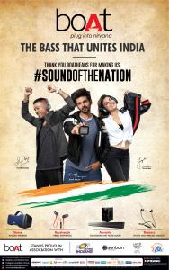

**DEMERITS TO CUSTOMER FROM THE BOAT LIFESTYLE:**

**Here are some potential demerits that customers may experience with Boat Lifestyle:**

**Product-Related Demerits:**

**1. Quality control issues: Some customers may experience quality control issues, such as defective products or inconsistent sound quality.**

**2. Limited product range: Boat Lifestyle’s product range may be limited compared to other brands, which could restrict customer choice.**

**3. Compatibility issues: Some Boat Lifestyle products may not be compatible with all devices or platforms, which could lead to frustration for customers.**

**Service-Related Demerits:**

**1. Customer support limitations: Boat Lifestyle’s customer support may not be available 24/7 or in multiple languages, which could be a drawback for international customers.**

**2. Returns and refunds process: The returns and refunds process may be cumbersome or time-consuming, which could lead to dissatisfaction among customers.**

**3. Limited physical presence: Boat Lifestyle’s limited physical presence may make it difficult for customers to try before they buy or receive in-person support.**

**Warranty and After-Sales Demerits:**

**1. Limited warranty period: Boat Lifestyle’s warranty period may be limited, which could leave customers with limited protection against defects or issues.**

**2. Repair and replacement delays: Customers may experience delays in repairing or replacing defective products, which could lead to frustration and inconvenience.**

**3. Limited after-sales support: Boat Lifestyle’s after-sales support may be limited, which could leave customers with unanswered questions or unresolved issues.**

**Loyalty and Rewards Demerits:**

**1. Limited loyalty program benefits: Boat Lifestyle’s loyalty program benefits may be limited, which could make it less appealing to customers.**

**2. Difficulty in redeeming rewards: Customers may experience difficulty in redeeming rewards or points, which could lead to frustration and disappointment.**

**3. Limited exclusive offers: Boat Lifestyle’s exclusive offers and promotions may be limited, which could make customers feel like they’re missing out on benefits.**

**By acknowledging these potential demerits, Boat Lifestyle can take steps to address these issues and improve its products, services, and overall customer experience.**

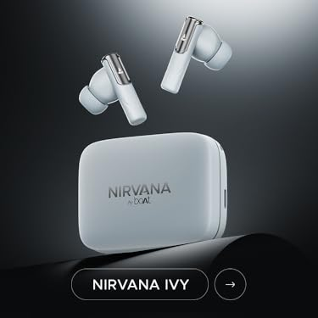

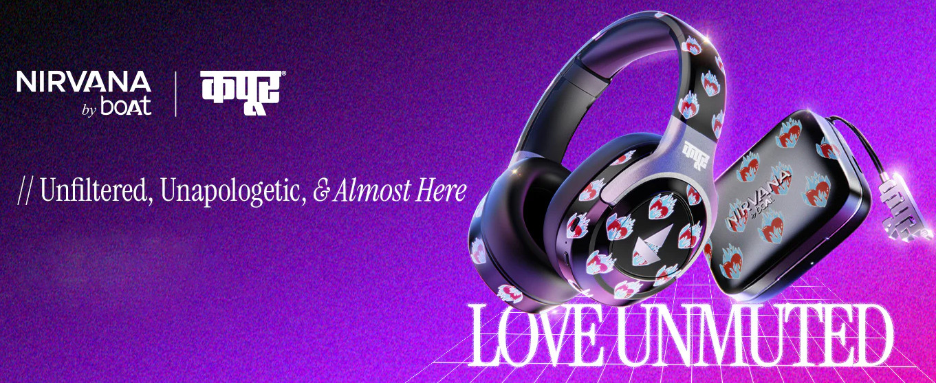

**KEY TAKEAWAYS:**

**1. Strong brand foundation: Boat Lifestyle has established a solid brand identity, with a clear mission, vision, and values.**

**2. Comprehensive digital marketing strategy: The company has a well-rounded digital marketing approach, incorporating SEO, content marketing, social media, email marketing, and influencer partnerships.**

**3. Content creation and curation: Boat Lifestyle has a robust content library, with engaging blog posts, social media content, videos, and email newsletters.**

**4. Targeted advertising: The company has executed targeted ad campaigns across social media platforms, reaching the desired audience and driving conversions.**

**RECOMMENDATIONS FOR FUTURE GROWTH:**

**1. Continuously monitor and optimize digital marketing efforts: Regularly analyze metrics, adjust strategies, and refine targeting to ensure maximum ROI.**

**2. Explore new content formats and channels: Consider podcasting, live streaming, and other emerging formats to stay ahead of the competition.**

**3. Enhance email marketing automation: Develop more sophisticated automated email sequences to nurture leads and encourage conversions.**

**4. Invest in influencer partnerships and user-generated content: Collaborate with influencers and encourage customers to share their experiences with Boat Lifestyle products.**

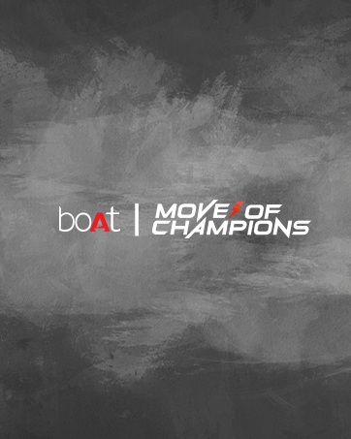**OVERALL ASSESSMENT: Boat Lifestyle has demonstrated a strong commitment to digital**

**marketing, content creation, and customer engagement. By continuing to refine its strategies, exploring new channels and formats, and investing in influencer partnerships and automation, the company is well-positioned for sustained growth and**

**success in the competitive consumer electronics industry.**

**CONCLUSION:**

**In conclusion, Boat Lifestyle is a popular Indian company that offers a range of affordable, stylish, and high-quality audio products and lifestyle accessories.**

**Boat Lifestyle is a promising Indian company that has disrupted the audio products market with its affordable and stylish offerings. While it has some weaknesses, its strengths in terms of pricing, design, and customer support make it a popular choice among young and fashion-conscious customers. With further expansion of its product range and international presence, Boat Lifestyle has the potential to become a leading global brand in the audio products and lifestyle accessories market.**

